SPH4U0 Newton’s Laws Review and Activity Date:_______________
Sir Isaac Newton is famous for his three laws of motion as well as for his studies of gravity and optics.
Use the terms below to complete the summary of Newton’s Three Laws:
First Law Second Law Third Law
rest velocity mass
action reaction equal
unbalanced accelerate constant
zero inertia opposite

Newton’s ______________________ states that if the net force on an object is zero then the object will continue in a state of ___________ or ______________ ______________. The property of an body to maintain the same state of motion is referred to as ______________. This depends only on an object’s ________.

Newton’s __________________ applies when the forces on an object are _________________. If the net force on an object is not _____________, then the object will _____________ in the direction of the net force.
Newton’s ____________________ is often referred to as the ______________- _____________
Law. It states that if object A exerts a force on object B, then object B exerts an _____________
and ___________________ force on object A.

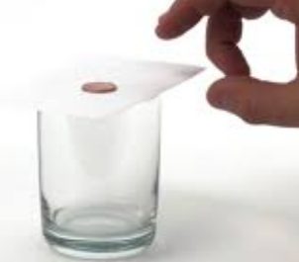
Investigation of Newton’s First Law and Second Laws: The Coin and the Card Trick
Place a coin on top of a cue card and place the card over the mouth
of a beaker. Flick the card with your fingers as shown to move it rapidly
sideways.
1. Use Newton’s First Law to explain the coin’s behavior:

2. Now try to move the card SLOWLY sideways by holding it between two fingers and pulling gently.
What happens to the coin in this case? Explain the behavior of the coin by referring to Newton’s Second Law!

Third Law Investigation: Balloon “Rocket”
1.Blow up a balloon and pinch the mouth of the balloon closed. Predict what will happen when you release the balloon. Prediction:

2. Refer to Newton’s 3rd Law to explain your observation. Draw an “action-reaction” diagram to support your explanation.

